
December 25, 2025
Christmas Day
Holy Eucharist
at 10:00 am
1570 Yonge Street, Toronto
416-920-5211
info@christchurchdeerpark.org

Merry Christmas! We’re so glad you’re here.

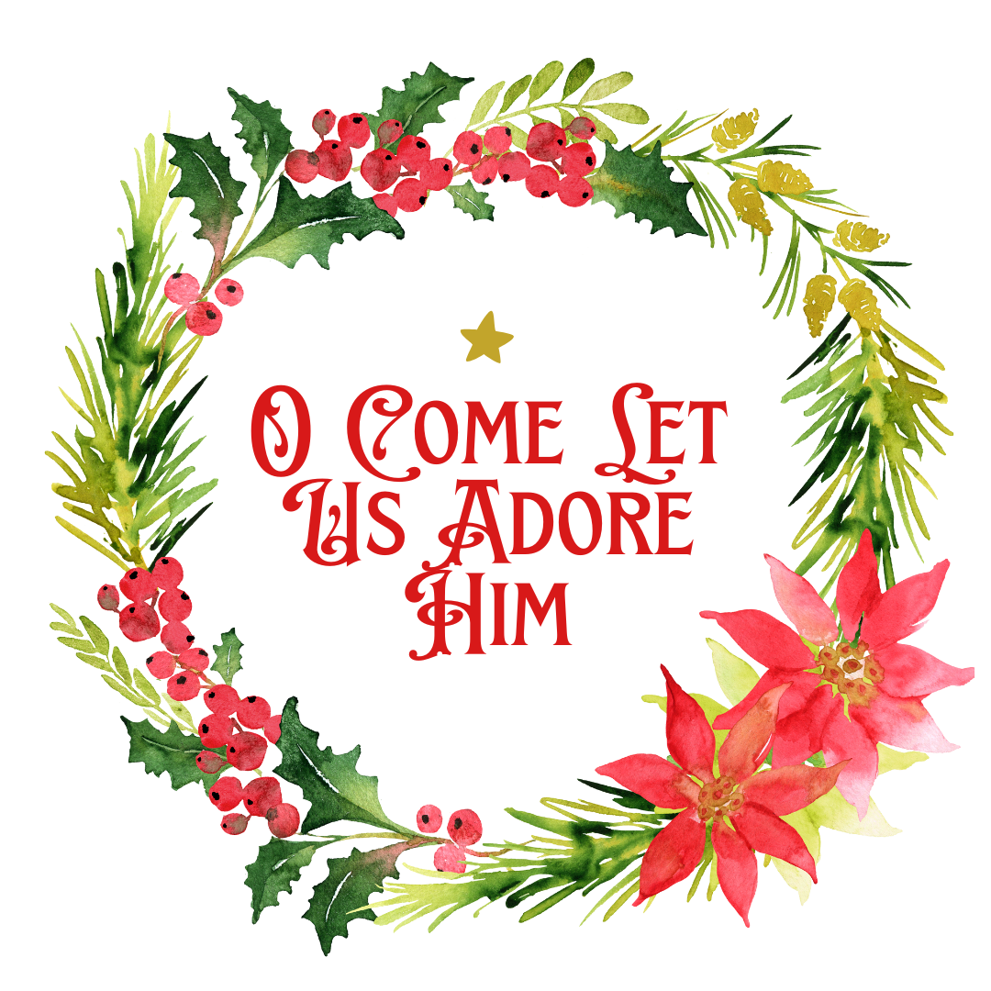

All are welcome to receive communion with us.
- To receive the bread, hold your hands in front of you, palms up.
- To receive the wine from the cup, take the bottom of the cup and the base and guide it to your mouth. (Dipping bread into wine is not permitted for health reasons.)
- If you prefer to take only the bread, you may indicate this to the cup bearer by crossing your arms over your chest, or simply walking past them.
- If you prefer simply to receive a blessing, as you reach the priest with the bread, cross your arms over your chest. Return to your seat after receiving the blessing.
- The response to receiving bread, wine, or a blessing is “Amen.”

Land Acknowledgement
We acknowledge the land on which we worship is the traditional territory of many nations including the Mississaugas of the Credit, the Anishinabek, the Chippewa, the Haudenosaunee and the Wendat peoples. This territory is part of the Dish with One Spoon Treaty, an agreement between the Anishinabek, Haudenosaunee, and allied nations to peaceably share and care for the resources around the Great Lakes.
Today, Toronto is still home to many Indigenous people from across Turtle Island (North America) and we seek to live in respect, peace, and right relations with them as we meet and worship on their territory. We are grateful for the resources we are using, and honour all the First Nations, Métis, and Inuit people who have been living on this land since time immemorial.

Visitor Information
All hymns are from the blue hymnal: Common Praise (CP). Hearing Assistance Devices are located on the table beside the bell-tower entrance. Large Print Orders of Service are available.
Preludes What is this Lovely Fragrance? Paul Manz
Cradle Song "Away in a Manger" Malcolm Archer
Prelude on Quem Pastores "He Whom the Shepherds Praised" Healey Willan

Presider: Welcome

The Gathering of the Community

Opening Hymn – Angels from the Realms of Glory (vs. 1, 2, 5)– CP #143 REGENT SQUARE

Angels, from the realms of glory,
wing your flight o'er all the earth;
you who sang creation's story,
now proclaim Messiah's birth:

Refrain
Come and worship, come and worship
worship Christ, the new-born King.

Shepherds in the field abiding,
watching o'er your flocks by night,
God with us is now residing;
yonder shines the infant Light. Refrain

Though an infant now we view him,
he shall fill th’eternal throne,
gather all the nations to him;
every knee shall then bow down. Refrain

Apostolic Greeting (please remain standing)
Presider The grace of our Lord Jesus Christ, and the love of God, and the fellowship of the Holy Spirit, be with you all.
All And also with you.

Collect for Purity
Presider Almighty and everlasting God,
All to you all hearts are open, all desires known, and from you no secrets are hidden. Cleanse the thoughts of our hearts by the inspiration of your Holy Spirit, that we may perfectly love you, and worthily magnify your holy name; through Christ our Lord. Amen.

Gloria –Christmas Gloria (based on In Dulci Jubilo and the Coventry Carol) Philip Ledger
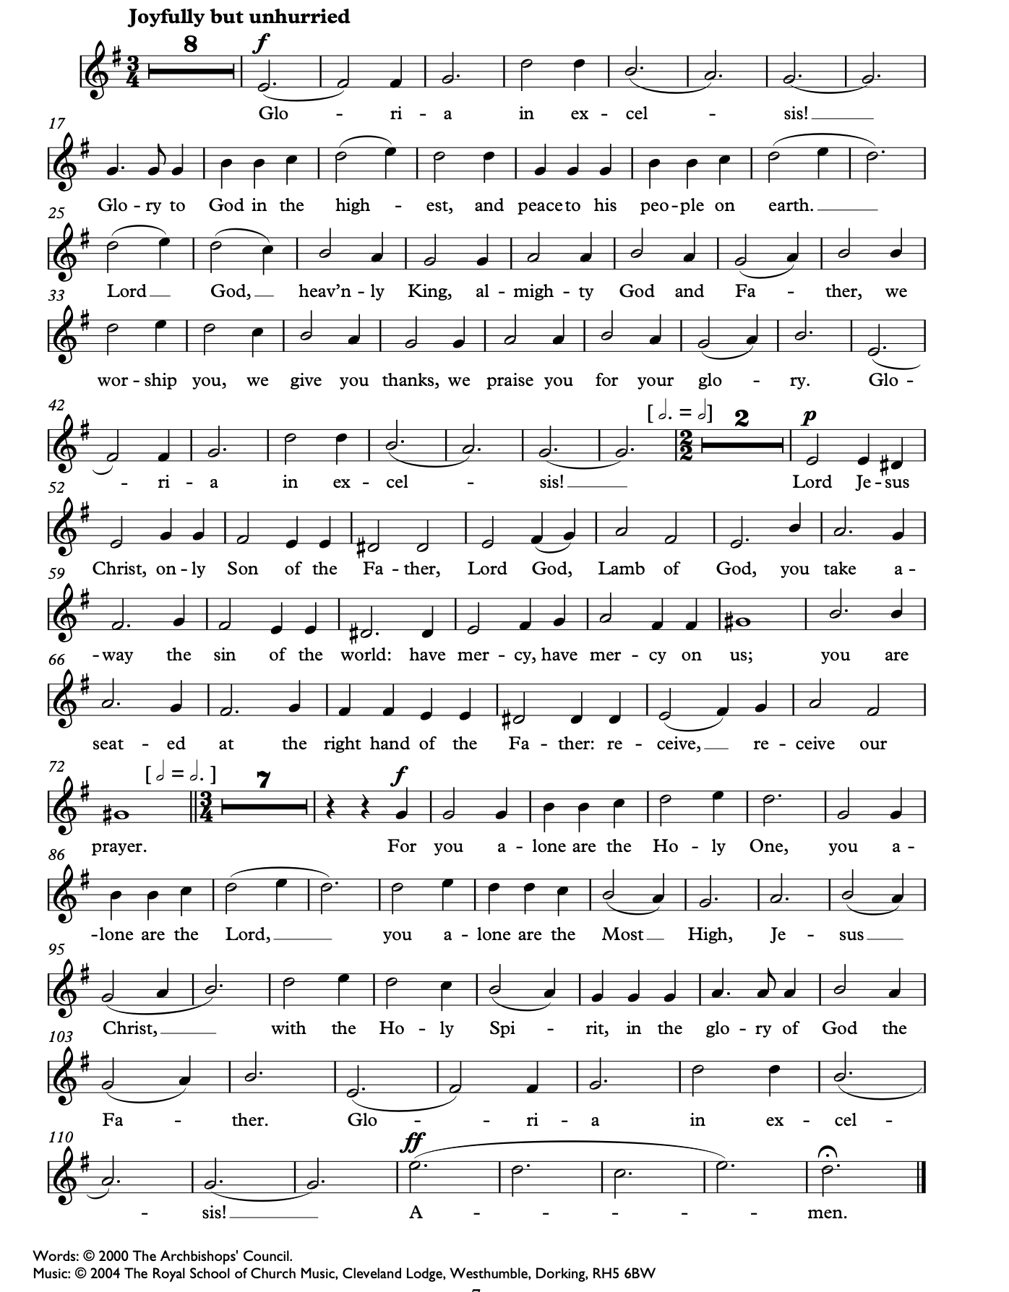
The Collect of the Day
Presider Almighty God, you wonderfully created and yet more wonderfully restored our human nature. May we share the divine life of your Son Jesus Christ, who humbled himself to share our humanity, and now lives and reigns with you and the Holy Spirit, one God, now and for ever. Amen.

The Proclamation of the Word

Presider Let us prepare ourselves for the Word of God as it comes to us in the reading

of Holy Scripture.
All Our hearts and minds are open.

First Reading (George Lewis) (please be seated)
Reader A reading from Isaiah.

How beautiful upon the mountains are the feet of the messenger who announces peace, who brings good news, who announces salvation, who says to Zion, ‘Your God reigns.’ Listen! Your sentinels lift up their voices, together they sing for joy; for in plain sight they see the return of the Lord to Zion. Break forth together into singing, you ruins of Jerusalem; for the Lord has comforted his people, he has redeemed Jerusalem. The Lord has bared his holy arm before the eyes of all the nations; and all the ends of the earth shall see the salvation of our God.
Isaiah 52:7-10 (NRSVA)
Reader Hear what the Spirit is saying to the Church.
All Thanks be to God.

Psalm 98 Based on “Adeste Fideles”
The refrain is first sung by the cantor, then by all.
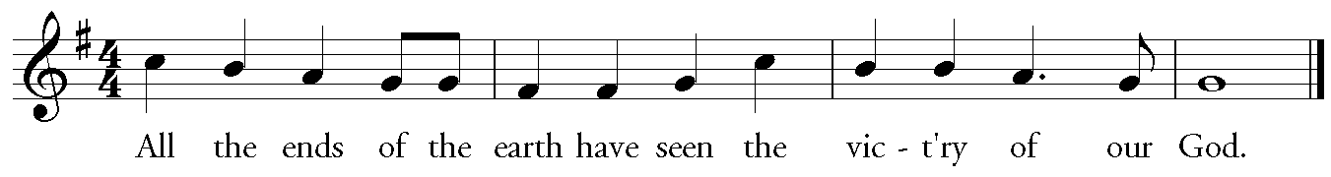
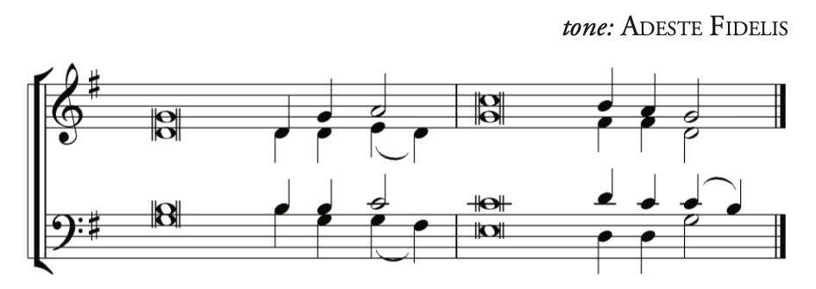
Music: From the St. Martin Psalter | used with permission by St. James Music Press, license #29107

Cantor Sing to the [Lord a] new song,*
for he has done [marv]-’lous things.
All With his right hand and his [ho]-ly arm*
has he won for him-[self] the victory.
Choir The Lord has made [known] his victory;*
his righteousness has he openly shown in the [sight of] the nations.
All He remembers his mercy and faithfulness to the [house] of Israel,*
and all the ends of the earth have seen the victory [of] our God.

Refrain

Cantor Shout with joy to the [Lord all] you lands;*
lift up your voice, re-[joice] and sing.
All Sing to the [Lord with] the harp,*
with the harp and the [voice] of song.
Choir With trumpets and the [sound of] the horn*
shout with joy before the [king] the Lord.
All Let the sea make a noise and [all that] is in it,*
the lands and those who [dwell] therein.

Refrain

Choir Let the rivers [clap] their hands,*
and let the hills ring out with joy before the Lord,
when he comes to [judge] the earth.
All In righteousness shall he [judge] the world*
and the [peoples] with equity.

Refrain
Second Reading (George Lewis)
Reader A reading from the Letter to the Hebrews.

Long ago God spoke to our ancestors in many and various ways by the prophets, but in these last days he has spoken to us by a Son, whom he appointed heir of all things, through whom he also created the worlds. He is the reflection of God’s glory and the exact imprint of God’s very being, and he sustains all things by his powerful word. When he had made purification for sins, he sat down at the right hand of the Majesty on high, having become as much superior to angels as the name he has inherited is more excellent than theirs.

For to which of the angels did God ever say, ‘You are my Son; today I have begotten you’? Or again, ‘I will be his Father, and he will be my Son’? And again, when he brings the firstborn into the world, he says, ‘Let all God’s angels worship him.’ Of the angels he says, ‘He makes his angels winds, and his servants flames of fire.’ But of the Son he says, ‘Your throne, O God, is for ever and ever, and the righteous sceptre is the sceptre of your kingdom. You have loved righteousness and hated wickedness; therefore God, your God, has anointed you with the oil of gladness beyond your companions.’ And, ‘In the beginning, Lord, you founded the earth, and the heavens are the work of your hands; they will perish, but you remain; they will all wear out like clothing; like a cloak you will roll them up, and like clothing they will be changed. But you are the same, and your years will never end.’
Hebrews 1:1-12 (NRSVA)
Reader Hear what the Spirit is saying to the Church.
All Thanks be to God.

(please stand as you are able)
Sequence Hymn – Of Eternal Love Begotten (vs. 1, 2) – CP #132 DIVINUM MYSTERIUM

Of eternal love begotten, ere the worlds began to be,
he is Alpha and Omega, he the source, the ending he,
of the things that are, that have been, and that future years shall see,
evermore and evermore.

At his Word the worlds were framed. He commanded, it was done:
heaven and earth and depths of ocean, in their threefold order one;
all that grows beneath the shining, of the moon and burning sun,
evermore and evermore.

Text: Aurelius Clemens Prudentius, tr. John Mason Neale
Music: Plainsong, Mode 8

The Holy Gospel
Gospeller The Lord be with you.
All And also with you.
Gospeller The Holy Gospel of our Lord Jesus Christ according to John.
All Glory to you, Lord Jesus Christ.

In the beginning was the Word, and the Word was with God, and the Word was God. He was in the beginning with God. All things came into being through him, and without him not one thing came into being. What has come into being in him was life, and the life was the light of all people. The light shines in the darkness, and the darkness did not overcome it.

There was a man sent from God, whose name was John. He came as a witness to testify to the light, so that all might believe through him. He himself was not the light, but he came to testify to the light. The true light, which enlightens everyone, was coming into the world.

He was in the world, and the world came into being through him; yet the world did not know him. He came to what was his own, and his own people did not accept him. But to all who received him, who believed in his name, he gave power to become children of God, who were born, not of blood or of the will of the flesh or of the will of man, but of God.

And the Word became flesh and lived among us, and we have seen his glory, the glory as of a father’s only son, full of grace and truth.
John 1:1-14 (NRSVA)

Gospeller The Gospel of Christ.
All Praise to you, Lord Jesus Christ.

Sequence Hymn – Of Eternal Love Begotten (vs. 5, 6) – CP #132

O ye heights of heaven, adore him; Angel hosts, his praises sing;
All dominions, bow before him, And extol our God and king;
Let no tongue on earth be silent, Every voice in concert ring,
evermore and evermore.

Christ, to thee, with God the Father, and, O Holy Ghost, to thee,
hymn and chant and high thanksgiving, and unwearied praises be,
honour, glory, and dominion, and eternal victory,
evermore and evermore.

Sermon (please be seated)

Music for Reflection
The Nicene Creed (please stand as you are able)
John Merbecke
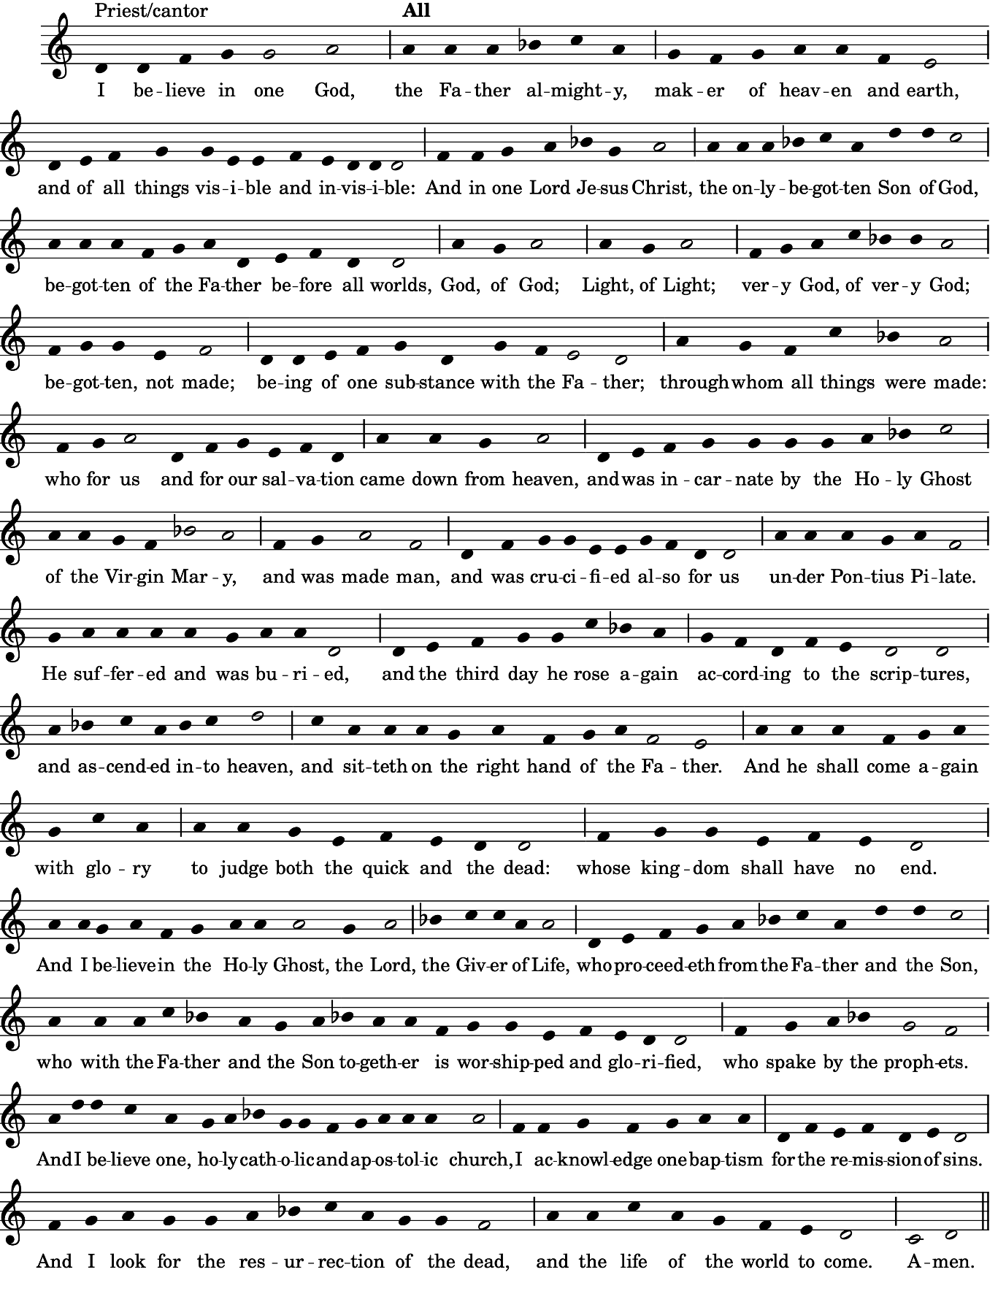
Prayers of the People (Paul Kingston) (please stand, kneel, or sit as you are able)

Presider: Because it is Christmas we are going directly to the peace.

Confession and Absolution
Presider Dear friends in Christ, God is steadfast in love and infinite in mercy; he welcomes sinners and invites them to his table. Let us confess our sins, confident in God’s forgiveness.

Presider Most merciful God,
All We confess that we have sinned against you in thought, word, and deed, by what we have done, and by what we have left undone. We have not loved you with our whole heart; we have not loved our neighbours as ourselves. We are truly sorry and we humbly repent. For the sake of your Son Jesus Christ, have mercy on us and forgive us, that we may delight in your will, and walk in your ways, to the glory of your name. Amen.
Presider Almighty God have mercy upon you, pardon and deliver you from all your sins, confirm and strengthen you in all goodness, and keep you in eternal life; through Jesus Christ our Lord.
All Amen.

The Peace (please remain standing)
Presider Peace be with you.
All And also with you.

Offertory Hymn – I Saw Three Ships Traditional
I saw three ships come sailing in
On Christmas day, on Christmas day;
I saw three ships come sailing in
On Christmas day in the morning.

And what was in those ships all three,
On Christmas day, on Christmas day?
And what was in those ships all three,
On Christmas day in the morning?

Our Saviour Christ and His lady,
On Christmas day, on Christmas day;
Our Savior Christ and His lady,
On Christmas day in the morning.

And all the Souls on Earth shall sing,
⁠On Christmas day, on Christmas day;
And all the Souls on Earth shall sing,
⁠On Christmas day in the morning.

Then let us all rejoice amain,
⁠On Christmas day, on Christmas day;
Then let us all rejoice amain,
⁠On Christmas day in the morning.

Prayer over the Gifts
Presider God of peace, your Son Jesus Christ has reconciled us to you. May all we offer you today renew us as members of your household. We ask this in his name. Amen.

The Celebration of the Eucharist

Eucharistic Prayer 3 (please remain standing)

Presider The Lord be with you.
People And also with you.

Presider Lift up your hearts.
People We lift them to the Lord.

Presider Let us give thanks to the Lord our God.
People It is right to give our thanks and praise.

Presider Blessed are you, gracious God, creator of heaven and earth; we give you thanks and praise through Jesus Christ our Lord, who in the fullness of time came among us in our flesh, and opened to us the way of salvation. Now we watch for the day when he will come again in power and great triumph to judge this world, that we, without shame or fear, may rejoice to behold his appearing. Therefore we praise you, joining our voices with angels and archangels and with all the company of heaven, who for ever sing this hymn to proclaim the glory of your name.

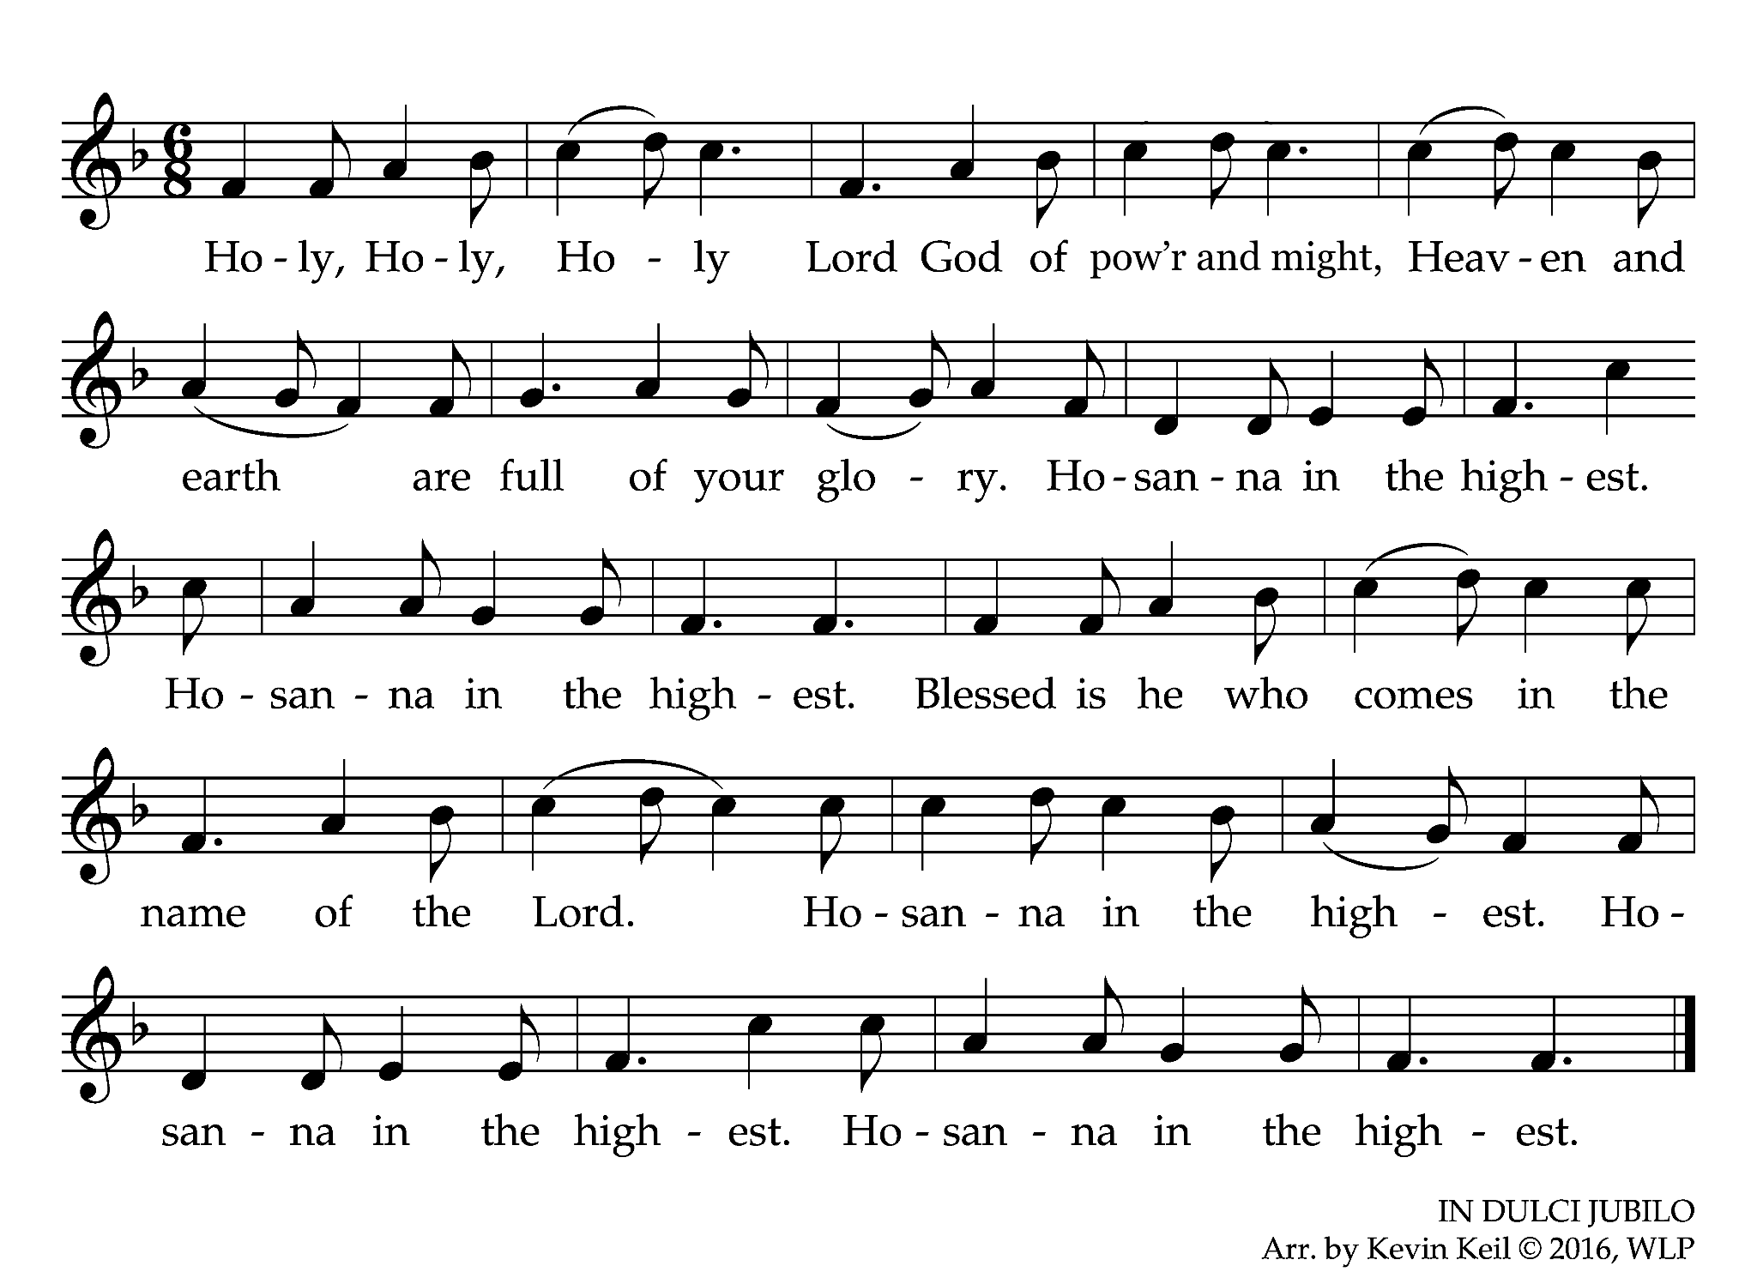
Presider
We give thanks to you, Lord our God, for the goodness and love you have made known to us in creation; in calling Israel to be your people; in your Word spoken through the prophets; and above all in the Word made flesh, Jesus your Son. For in these last days you sent him to be incarnate from the Virgin Mary, to be the Saviour and Redeemer of the world. In him, you have delivered us from evil, and made us worthy to stand before you. In him, you have brought us out of error into truth, out of sin into righteousness, out of death into life. On the night he was handed over to suffering and death, a death he freely accepted, our Lord Jesus Christ took bread; and when he had given thanks to you, he broke it, and gave it to his disciples, and said, “Take, eat: this is my body which is given for you. Do this for the remembrance of me.”

After supper he took the cup of wine; and when he had given thanks, he gave it to them
and said, “Drink this, all of you: this is my blood of the new covenant, which is shed for
you and for many for the forgiveness of sins. Whenever you drink it, do this for the
remembrance of me.”

Presider Therefore, Father, according to his command,

People we remember his death,
we proclaim his resurrection,
we await his coming in glory;

Presider and we offer our sacrifice of praise and thanksgiving to you, Lord of all; presenting to you, from your creation, this bread and this wine. We pray you, gracious God, to send your Holy Spirit upon these gifts, that they may be the sacrament of the body of Christ and his blood of the new covenant. Unite us to your Son in his sacrifice, that we, made acceptable in him, may be sanctified by the Holy Spirit. In the fullness of time, reconcile all things in Christ, and make them new, and bring us to that city of light where you dwell with all your sons and daughters; through Jesus Christ our Lord, the firstborn of all creation, the head of the Church, and the author of our salvation; by whom, and with whom, and in whom, in the unity of the Holy Spirit, all honour and glory are yours, almighty Father, now and for ever.
All Amen

The Lord's Prayer John Merbecke
Presider As our Saviour taught us, let us pray,
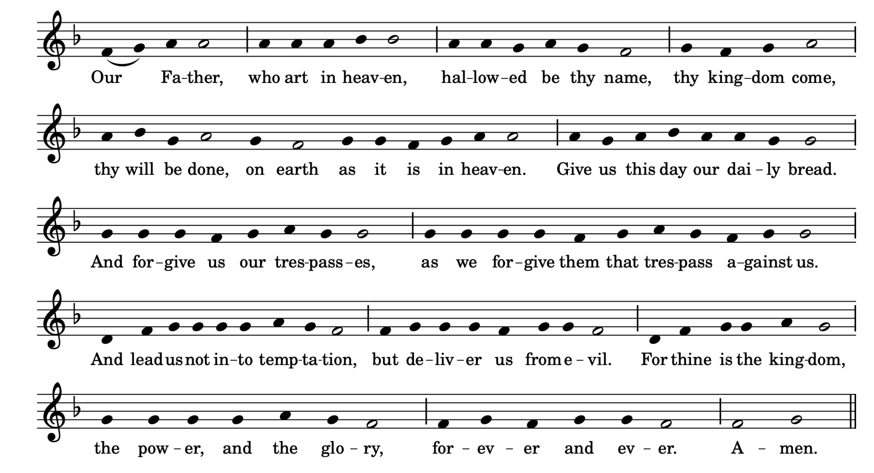

Breaking of the Bread
Presider We break the bread of life, and that life is the light of the world.
All God here among us, light in the midst of us, bring us to light and life.

Presider The gifts of God for the People of God.
All Thanks be to God.
(please be seated in prayer)
Agnus Dei – Christmas Mass for St. William’s Richard Shephard
Choir Lamb of God, you take away the sins of the world: have mercy on us.
Lamb of God, you take away the sins of the world: have mercy on us.
Lamb of God, you take away the sins of the world: grant us peace.
Choral Anthem – The Holly and the Ivy English traditional

Choir The holly and the ivy,
When they are both full grown,
Of all the trees that are in the wood,
The holly bears the crown.

Refrain
The rising of the sun
And the running of the deer,
The playing of the merry organ,
Sweet singing in the choir.

The holly bears a blossom,
As white as the lily flower,
And Mary bore sweet Jesus Christ,
To be our sweet Saviour. Refrain

The holly bears a berry,
As red as any blood,
And Mary bore sweet Jesus Christ
For to do us sinners good. Refrain
The holly bears a prickle,
As sharp as any thorn,
And Mary bore sweet Jesus Christ
On Christmas Day in the morn. Refrain

The holly bears a bark,
As bitter as any gall,
And Mary bore sweet Jesus Christ
To redeem us all. Refrain

The holly and the ivy,
When they are both full grown,
Of all the trees that are in the wood,
The holly bears the crown. Refrain

Text and music: English traditional

Prayer after Communion (please stand as you are able)
Presider God of all, the child born for us is the Saviour of the world. May he who made us your children welcome us into your kingdom, where he is alive and reigns with you now and for ever. Amen.

Blessing

Announcements – Refer to the separate announcements bulletin.

Closing Hymn – Hark, the Herald Angels Sing – CP #138 MENDELSSOHN

Hark! The herald angels sing, “Glory to the newborn King,
peace on earth, and mercy mild, God and sinners reconciled.”
Joyful, all ye nations, rise, join the triumph of the skies;
with the angelic host proclaim, “Christ is born in Bethlehem!”
Hark! The herald angels sing, “Glory to the newborn king.”

Christ by highest heaven adored; Christ, the everlasting Lord;
late in time behold him come, offspring of a virgin’s womb.
Veiled in flesh the Godhead see; hail, the incarnate deity,
pleased as one of us to dwell, Jesus, our Emmanuel.
Hark! The herald angels sing, “Glory to the newborn king.”

Hail, the heaven-born Prince of Peace! Hail, the Sun of Righteousness!
Light and life to all he brings, risen with healing in his wings.
Mild he lays his glory by, born that we no more may die,
born to raise each child of earth, born to give us second birth.
Hark! The herald angels sing, “Glory to the newborn king.”
Text: C. Wesley
Music: F. Mendelssohn; adapt. W. Cummings

Dismissal

Presider Followers of Jesus, inspired by the Holy Spirit, serve the world God loves!

All Thanks be to God.

Postlude Postlude on "Il Est Né Le Divin Enfant" Denis Bédard

Assisting with the Liturgy

Presider & Preacher: Cathy Gibbs

Crucifier: Sunkanmi Kazeem

Subdeacon: Elsa Jones

Director of Music & Organist: Stefani Bedin

Vocal Quintet: Maren Richardson, Emily Ding, Julia Barber,
Martin So, Peter Warren

Reader: George Lewis

Prayers: Paul Kingston

Warden on Duty: Paul Kingston

Greeter: Ted White

Livestream Technician: Nate Denton

Verger: Rikk Scapillato

Leadership & Staff
The Rev. Canon Dr. Alison Falby – Incumbent afalby@christchurchdeerpark.org
The Rev. Cathy Gibbs – Adult Education cgibbs@christchurchdeerpark.org
Stefani Bedin – Director of Music sbedin@christchurchdeerpark.org
Bryan Tran – Director of Parish Operations & Bookkeeper btran@christchurchdeerpark.org
Stephen Clark – Rector’s Warden Paul Kingston – People’s Warden
Katherine MacDonald – Deputy Warden Nick Strube – Treasurer
Ahna DiFelice – Parish Administrator adifelice@christchurchdeerpark.org
Denis Delisle, Rikk Scapillato – Lead Custodians Carlos Lopez, Godwin Njeteneh – Custodial Team

Ways to Serve & Get Involved
Community Breakfast – Carl Wehniainen, Lead outreach@christchurchdeerpark.org
Congregational Care Team – Ann Atkins, Lead communitycare@christchurchdeerpark.org
Prayer Circle – Jan D’Angelo, Coordinator prayercircle@christchurchdeerpark.org

Small Groups – The Rev. Cathy Gibbs Choir –Stefani Bedin, Director
Coffee Hour – Sandra Geddes, Coordinator Hospitality – Jayne Miles Simpson, Lead
Chancel Guild – Elsa Jones, Lead Readers & Intercessors – The Rev. Alison Falby
Children’s Ministry – Sharilyn Robinson Welcome Team – Paul Kingston, Coordinator
Refugee Committee – Julie Scott, Chair Property Committee – Andrew Harding, Chair
Stewardship Committee – Amy Leung, Chair Investment Committee – George Lewis, Chair
Truth and Reconciliation – Mary Bredin, Lead Climate Action Group – Brad Lennon, Lead
Rummage Re-Imagined – Jayne Miles Simpson, Lead Christmas Sale – Jayne Miles Simpson, Lead
Spiritus – Emily Chatten, Melissa Walter, Editorial Team Churches on the Hill Foodbank – Ted Southey, Lead

If you would like to contact a ministry or group leader, please email or phone the office.

Participating in the Offertory
Thank you for your faithful generosity. Running our church is a significant undertaking that allows us to serve our congregation and the neighbourhood. Our essential weekly operating costs total approximately $20,000. Your contributions support everything from maintaining our sacred space to funding vital community programs and staff salaries. Your ongoing support is deeply appreciated. For more information on how to make a regular financial contribution, speak to Bryan in the office or go to our website: https://christchurchdeerpark.org/give/

Ways to Give Financially
● Through automatic monthly credit card or pre-authorized debit donations.
● Cash or cheque made out to Christ Church Deer Park
● E-transfer to donations@christchurchdeerpark.org
- Online via Canada Helps (scan the QR code to be brought to the website)

Music reprinted & streamed with permission under Official tax receipts are issued on an annual basis to
One License #A-724916 and reprinted with permission those who give $20 or more. If you wish to receive a
under CCLI Inc. #11419375. All rights reserved. receipt, please enclose your gift in an envelope with
your name and address or donate online.

