
December 28, 2025
First Sunday after Christmas
Holy Eucharist
at 10:00 am
1570 Yonge Street, Toronto
416-920-5211
info@christchurchdeerpark.org

Welcome! We’re so glad you’re here.

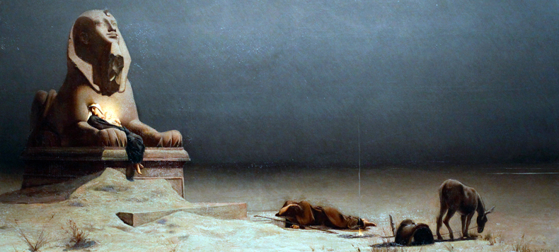
Luc Olivier Merson, Rest on the Flight into Egypt (1880). Wikimedia Commons.

All are welcome to receive communion with us.
- To receive the bread, hold your hands in front of you, palms up.
- To receive the wine from the cup, take the bottom of the cup and the base and guide it to your mouth. (Dipping bread into wine is not permitted for health reasons.)
- If you prefer to take only the bread, you may indicate this to the cup bearer by crossing your arms over your chest, or simply walking past them.
- If you prefer simply to receive a blessing, as you reach the priest with the bread, cross your arms over your chest. Return to your seat after receiving the blessing.
- The response to receiving bread, wine, or a blessing is “Amen.”

Land Acknowledgement
We acknowledge the land on which we worship is the traditional territory of many nations including the Mississaugas of the Credit, the Anishinabek, the Chippewa, the Haudenosaunee and the Wendat peoples. This territory is part of the Dish with One Spoon Treaty, an agreement between the Anishinabek, Haudenosaunee, and allied nations to peaceably share and care for the resources around the Great Lakes.
Today, Toronto is still home to many Indigenous people from across Turtle Island (North America) and we seek to live in respect, peace, and right relations with them as we meet and worship on their territory. We are grateful for the resources we are using, and honour all the First Nations, Métis, and Inuit people who have been living on this land since time immemorial.

Visitor Information
All hymns are from the blue hymnal: Common Praise (CP). Hearing Assistance Devices are located on the table beside the bell-tower entrance. Large Print Orders of Service are available.
Preludes Prelude on the Huron Carol Denis Bèdard
Noël Étranger Louis Daquin

Welcome

The Gathering of the Community

Opening Hymn – See Amid the Winter’s Snow – CP #148 SEE AMID THE WINTER’S SNOW

See amid the winter's snow,
born for us on earth below,
see, the tender Lamb appears,
promised from eternal years!

Refrain:
Hail, thou ever-blessed morn!
Hail, redemption's happy dawn!
Sing through all Jerusalem,
Christ is born in Bethlehem.

Lo, within a manger lies
he who built the starry skies,
who enthroned in height sublime
sits amid the cherubim. Refrain

Say, ye holy shepherds, say
what your joyful news today;
wherefore have ye left your sheep
on the lonely mountain steep? Refrain

"As we watched at dead of night,
lo, we saw a wondrous light;
angels singing 'Peace on earth'
told us of the Saviour's birth." Refrain

Sacred infant, all divine,
what a mighty love was thine,
thus to come from highest bliss
down to such a world as this! Refrain

Text: Edward Caswall
Music: John Goss

Apostolic Greeting (please remain standing)
Presider The grace of our Lord Jesus Christ, and the love of God, and the fellowship of the Holy Spirit, be with you all.
All And also with you.

Collect for Purity
Presider Almighty and everlasting God,
All to you all hearts are open, all desires known, and from you no secrets are hidden. Cleanse the thoughts of our hearts by the inspiration of your Holy Spirit, that we may perfectly love you, and worthily magnify your holy name; through Christ our Lord. Amen.

Gloria REGENT SQUARE

Glory be to God in heaven,
Songs of joy and peace we bring,
Thankful hearts and voices raising,
To creation’s Lord we sing:
Lord, we thank you, Lord, we bless you,
Glory be to God our king.

Lamb of God who on your shoulders,
Bore the load of this world’s sin,
Only Son of God the Father,
You have brought us peace within.
Lord, have mercy, Christ, have mercy,
Now your glorious reign begin.

You, O Son of God, are holy,
You we praise with one accord,
None in heav’n or earth is like you,
Only you are Christ the Lord,
With the Father, and the Spirit,
Ever worshipped and adored.

Text: paraphrase by Edwin Le Grice ©1991 Kevin Mayhew Ltd
Music: Henry Smart

The Collect of the Day
Presider Almighty God, you have shed upon us the new light of your incarnate Word. May this light, enkindled in our hearts, shine forth in our lives; through Jesus Christ our Lord, who lives and reigns with you, in the unity of the Holy Spirit, one God, now and for ever. Amen.

The Proclamation of the Word

Presider Let us prepare ourselves for the Word of God
as it comes to us in the reading of Holy Scripture.
All Our hearts and minds are open.

First Reading (please be seated)
Reader A reading from Isaiah.

I will recount the gracious deeds of the Lord, the praiseworthy acts of the Lord, because of all that the Lord has done for us, and the great favour to the house of Israel that he has shown them according to his mercy, according to the abundance of his steadfast love. For he said, ‘Surely they are my people, children who will not deal falsely’; and he became their saviour in all their distress. It was no messenger or angel but his presence that saved them; in his love and in his pity he redeemed them; he lifted them up and carried them all the days of old. Isaiah 63:7-9 (NRSVA)

Reader Hear what the Spirit is saying to the Church.
All Thanks be to God.

Psalm 111 Plainsong
The refrain is first sung by the cantor, then by all.
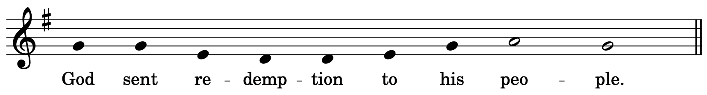
Cantor Hallelujah! I will give thanks to the Lord with my whole heart,
in the assembly of the upright, in the congregation.
Great are the deeds of the Lord!
they are studied by all who delight in them. Refrain

His work is full of majesty and splendour,
and his righteousness endures for ever.
He makes his marvellous works to be remembered;
the Lord is gracious and full of compassion. Refrain

He gives food to those who fear him;
he is ever mindful of his covenant.
He has shown his people the power of his works
in giving them the lands of the nations. Refrain

The works of his hands are faithfulness and justice;
all his commandments are sure.
They stand fast for ever and ever,
because they are done in truth and equity. Refrain
He sent redemption to his people; he commanded his covenant for ever;
holy and awesome is his name.
The fear of the Lord is the beginning of wisdom;
those who act accordingly have a good understanding; his praise endures for ever. Refrain

Second Reading
Reader A reading from the Letter to the Hebrews.

It was fitting that God, for whom and through whom all things exist, in bringing many children to glory, should make the pioneer of their salvation perfect through sufferings. For the one who sanctifies and those who are sanctified all have one Father. For this reason Jesus is not ashamed to call them brothers and sisters, saying, ‘I will proclaim your name to my brothers and sisters, in the midst of the congregation I will praise you.’ And again, ‘I will put my trust in him.’ And again, ‘Here am I and the children whom God has given me.’

Since, therefore, the children share flesh and blood, he himself likewise shared the same things, so that through death he might destroy the one who has the power of death, that is, the devil, and free those who all their lives were held in slavery by the fear of death. For it is clear that he did not come to help angels, but the descendants of Abraham. Therefore he had to become like his brothers and sisters in every respect, so that he might be a merciful and faithful high priest in the service of God, to make a sacrifice of atonement for the sins of the people. Because he himself was tested by what he suffered, he is able to help those who are being tested. Hebrews 2:10-18 (NRSVA)

Reader Hear what the Spirit is saying to the Church.
All Thanks be to God.

(please stand as you are able)
Gospel Acclamation – Alleluia Based on the Sussex Carol
The refrain is first sung by the cantor, then by all.
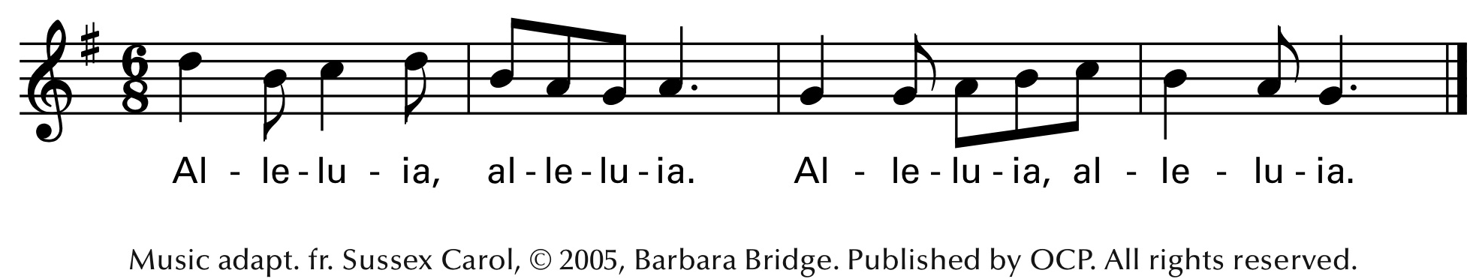

Cantor Let the peace of Christ rule in your hearts; let the word of Christ dwell in you richly.
Colossians 3.15, 16 (NRSVA)

The Holy Gospel
Gospeller The Lord be with you.
All And also with you.
Gospeller The Holy Gospel of our Lord Jesus Christ according to Matthew.
All Glory to you, Lord Jesus Christ.

Now after they had left, an angel of the Lord appeared to Joseph in a dream and said, ‘Get up, take the child and his mother, and flee to Egypt, and remain there until I tell you; for Herod is about to search for the child, to destroy him.’ Then Joseph got up, took the child and his mother by night, and went to Egypt, and remained there until the death of Herod. This was to fulfil what had been spoken by the Lord through the prophet, ‘Out of Egypt I have called my son.’

When Herod died, an angel of the Lord suddenly appeared in a dream to Joseph in Egypt and said, ‘Get up, take the child and his mother, and go to the land of Israel, for those who were seeking the child’s life are dead.’ Then Joseph got up, took the child and his mother, and went to the land of Israel. But when he heard that Archelaus was ruling over Judea in place of his father Herod, he was afraid to go there. And after being warned in a dream, he went away to the district of Galilee. There he made his home in a town called Nazareth, so that what had been spoken through the prophets might be fulfilled, ‘He will be called a Nazorean.’
Matthew 2:13-15, 19-23 (NRSVA)

Gospeller The Gospel of Christ.
All Praise to you, Lord Jesus Christ.

Carol Sing

The Apostles’ Creed (please stand as you are able)
All I believe in God, the Father almighty, creator of heaven and earth.

I believe in Jesus Christ, his only Son, our Lord.
He was conceived by the power of the Holy Spirit and born of the Virgin Mary.
He suffered under Pontius Pilate, was crucified, died, and was buried.
He descended to the dead.
On the third day he rose again.
He ascended into heaven, and is seated at the right hand of the Father.
He will come again to judge the living and the dead.

I believe in the Holy Spirit, the holy catholic Church, the communion of saints, the forgiveness of sins, the resurrection of the body, and the life everlasting.
Amen.

Prayers of the People (please stand, kneel, or sit as you are able)

Confession and Absolution
Presider Dear friends in Christ,
God is steadfast in love and infinite in mercy;
he welcomes sinners and invites us to his table.
Let us confess our sins, confident in God’s forgiveness.

Presider Most merciful God,
All We confess that we have sinned against you
in thought, word, and deed,
by what we have done,
and by what we have left undone.
We have not loved you with our whole heart;
we have not loved our neighbours as ourselves.
We are truly sorry and we humbly repent.
For the sake of your Son Jesus Christ,
have mercy on us and forgive us,
that we may delight in your will,
and walk in your ways,
to the glory of your name. Amen.

Presider Almighty God have mercy upon you,
pardon and deliver you from all your sins,
confirm and strengthen you in all goodness,
and keep you in eternal life;
through Jesus Christ our Lord.
All Amen.

The Peace (please remain standing)
Presider Peace be with you.
All And also with you.

The congregation is invited to remain standing for the offertory.

Offertory Hymn – God Rest Ye Merry Gentleman GOD REST YE MERRY

God rest ye merry, gentlemen,
Let nothing you dismay,
For Jesus Christ our Saviour
Was born upon this day,
To save us all from Satan's power
When we were gone astray.

Refrain:
O tidings of comfort and joy, comfort and joy,
O tidings of comfort and joy!

From God our heav'nly Father
A blessed angel came,
And unto certain shepherds
Brought tidings of the same,
How that in Bethlehem was born
The Son of God by name. Refrain

And when to Bethlehem they came,
Whereat this infant lay,
They found him in a manger,
Where oxen feed on hay;
His mother Mary kneeling,
Unto the Lord did pray: Refrain

Now to the Lord sing praises,
All you within this place,
And with true love and charity
Each other now embrace;
This holy tide of Christmas
All others shall replace. Refrain

Text and Music: English traditional carol, 18th c.

Prayer over the Gifts
Presider God of light,
in the birth of your Son we see your glory.
May we who share in this mystery grow daily in your love.
This we ask in the name of Jesus Christ the Lord.
Amen.

The Celebration of the Eucharist

Eucharistic Prayer 3 (please remain standing)
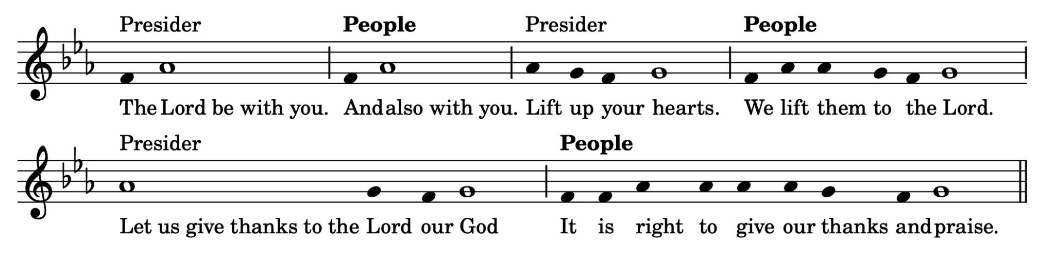

Presider Blessed are you, gracious God, creator of heaven and earth; we give you thanks and praise through Jesus Christ our Lord, who in the fullness of time came among us in our flesh, and opened to us the way of salvation. Now we watch for the day when he will come again in power and great triumph to judge this world, that we, without shame or fear, may rejoice to behold his appearing. Therefore we praise you, joining our voices with angels and archangels and with all the company of heaven, who for ever sing this hymn to proclaim the glory of your name.

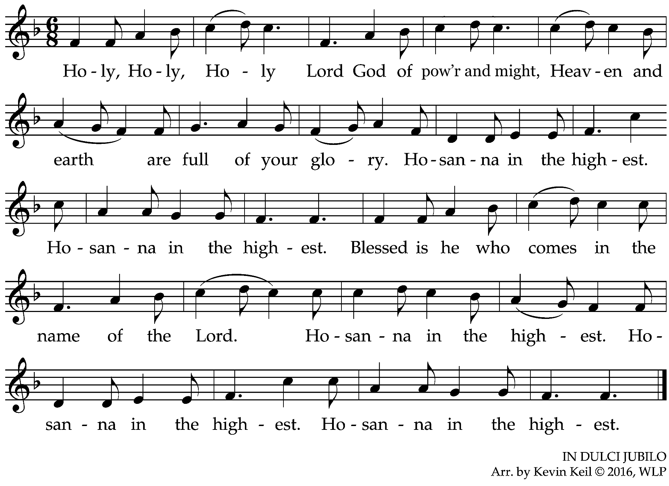

Presider We give thanks to you, Lord our God, for the goodness and love you have made known to us in creation; in calling Israel to be your people; in your Word spoken through the prophets; and above all in the Word made flesh, Jesus your Son. For in these last days you sent him to be incarnate from the Virgin Mary, to be the Saviour and Redeemer of the world. In him, you have delivered us from evil, and made us worthy to stand before you. In him, you have brought us out of error into truth, out of sin into righteousness, out of death into life. On the night he was handed over to suffering and death, a death he freely accepted, our Lord Jesus Christ took bread; and when he had given thanks to you, he broke it, and gave it to his disciples, and said, “Take, eat: this is my body which is given for you. Do this for the remembrance of me.” After supper he took the cup of wine; and when he had given thanks, he gave it to them, and said, “Drink this, all of you: this is my blood of the new covenant, which is shed for you and for many for the forgiveness of sins. Whenever you drink it, do this for the remembrance of me.”

Presider Therefore, Father, according to his command,

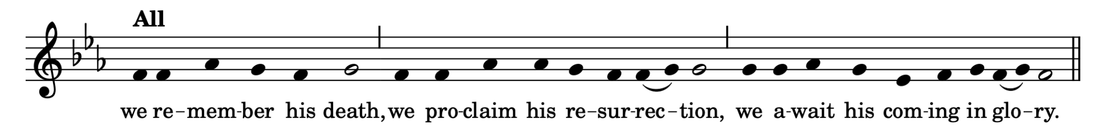

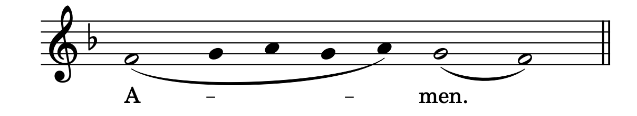
Presider and we offer our sacrifice of praise and thanksgiving to you, Lord of all; presenting to you, from your creation, this bread and this wine. We pray you, gracious God, to send your Holy Spirit upon these gifts, that they may be the sacrament of the body of Christ and his blood of the new covenant. Unite us to your Son in his sacrifice, that we, made acceptable in him, may be sanctified by the Holy Spirit. In the fullness of time, reconcile all things in Christ, and make them new, and bring us to that city of light where you dwell with all your sons and daughters; through Jesus Christ our Lord, the firstborn of all creation, the head of the Church, and the author of our salvation; by whom, and with whom, and in whom, in the unity of the Holy Spirit, all honour and glory are yours, almighty Father, now and for ever.
All

The Lord's Prayer John Merbecke
Presider As our Saviour taught us, let us pray,
All Our Father, who art in heaven, hallowed be thy name, thy kingdom come, thy will be done, on earth as it is in heaven. Give us this day our daily bread. And forgive us our trespasses, as we forgive those who trespass against us. And lead us not into temptation, but deliver us from evil. For thine is the kingdom, the power, and the glory, for ever and ever. Amen.
Breaking of the Bread
Presider We break the bread of life, and that life is the light of the world.
All God here among us, light in the midst of us, bring us to light and life.

Presider The gifts of God for the People of God.
All Thanks be to God.
(please be seated in prayer)
Agnus Dei – From “A Christmas Carol Mass” based on “The First Nowell”
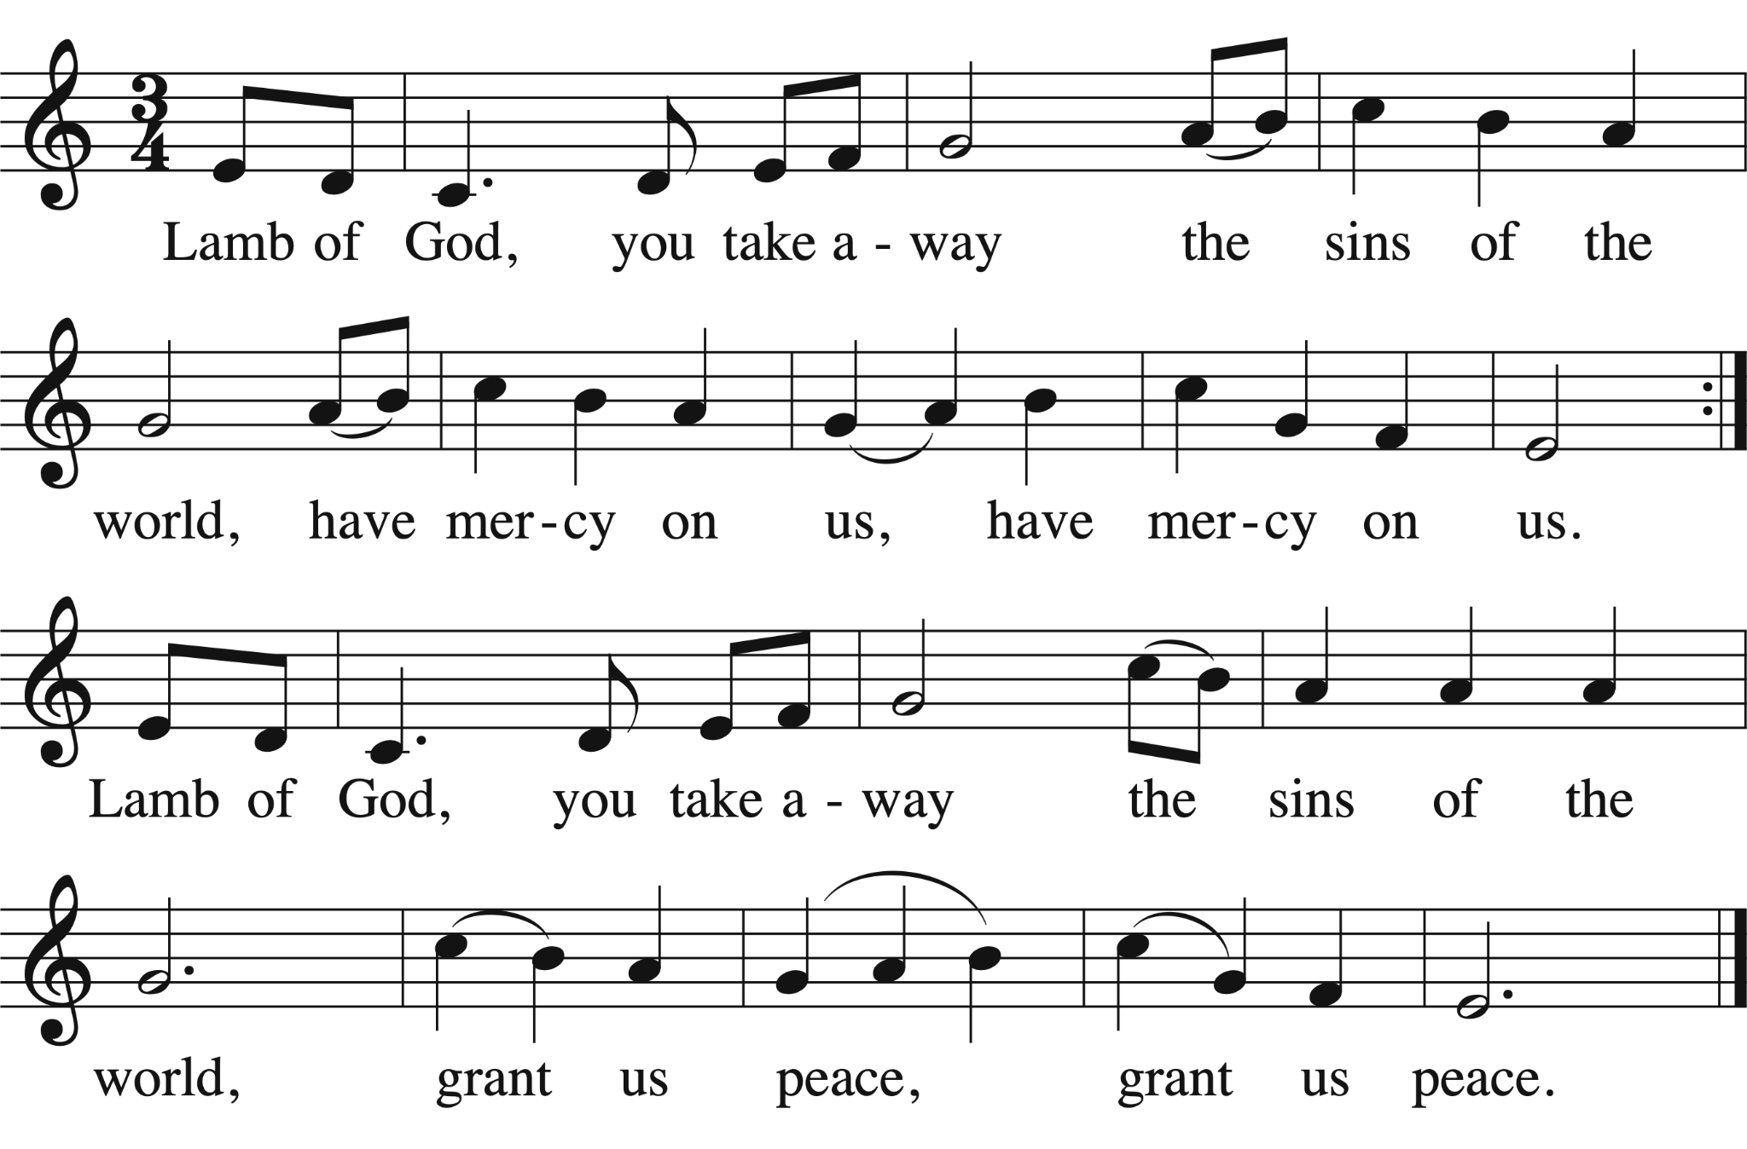
Music: Carroll .T Andrews, adapt. John Kyler Adapt. © 1966, 2022 GIA Publications, Inc.

Choral Anthem – Coventry Carol Traditional, arr. Henry Walford Davies

Choir Lully Lulla, thou little tiny child,
By by lully lullay.

O sisters too how may we do,
For to preserve this day,
This poor youngling for whom we do sing,
by by lully lullay.

Herod the king in his raging,
Charged he hath this day,
His man of might in his own sight,
All young children to slay.

That woe is me poor child for thee,
And ever mourn and say,
for thy parting, neither say nor sing,
by by lully lullay.

Lully Lulla, thou little tiny child,
By by lully lullay.
Worship Song – Child of the Poor / What Child is This? GREENSLEEVES

Child of the Poor

Helpless and hungry, lowly he lies,
wrapped in the chill of midwinter;
comes now among us,
born into poverty’s embrace,
new life for the world.

Refrain
Who is this who lives with the lowly,
sharing their sorrows, knowing their hunger?
This is Christ, revealed to the world
in the eyes of a child, a child of the poor.

Who is the stranger here in our midst,
looking for shelter among us?
Who is the outcast?
Who do we see amid the poor,
the children of God?

Bring all the thirsty, all who seek peace;
bring those with nothing to offer.
Strengthen the feeble,
say to the frightened heart:
“Fear not: here is your God!”

Text and Music: Scott Soper, ©1994 OCP
What Child is This?

What Child is this, who, laid to rest,
On Mary's lap is sleeping?
Whom angels greet with anthems sweet,
While shepherds watch are keeping?

This, this is Christ, the King, Whom shepherds guard and angels sing:
Haste, haste to bring Him laud,
The Babe, the Son of Mary!

Why lies He in such mean estate,
Where ox and ass are feeding?
Good Christian, fear: for sinners here
The silent Word is pleading.

So bring Him incense, gold, and myrrh,
Come, peasant, king to own Him.
The King of kings salvation brings;
Let loving hearts enthrone Him.

Text: W.C. Dix Music: English traditional

Prayer after Communion (please stand as you are able)
Presider Source of truth and joy, may we who have received the gift of divine life always follow the way of your Son. This we ask in the name of Jesus Christ the Lord. Amen.

Blessing
Presider May the birth of Jesus echo through your world with joy.
May the Spirit of Jesus guide your words and thoughts with love.
May the life of Jesus inspire you to follow his ways of peace to the time when the whole world is full of his glory once again.
All Amen.

Announcements – Refer to the separate announcements bulletin.

Closing Hymn – Good King Wenceslas – CP #145 TEMPUS ADEST FLORIDUM

All:
Good King Wenceslas looked out
on the feast of Stephen,
when the snow lay round about,
deep and crisp and even.
Brightly shone the moon that night,
though the frost was cruel,
when a poor man came in sight,
gathering winter fuel.

Lower voices:
“Hither, page, and stand by me,
if thou knowest it, telling:
yonder peasant, who is he?
Where and what his dwelling?”

Upper voices:
“Sire, he lives a good league hence,
underneath the mountain,
right against the forest fence,
by St. Agnes’ fountain.”

Lower voices:
“Bring me flesh and bring me wine,
bring me pinelogs hither;
thou and I will see him dine,
when we bear them thither.”
All: Page and monarch, forth they went,
forth they went together,
through the rude wind’s wild lament,
and the bitter weather.

Upper voices:
“Sire, the night is darker now,
and the wind blows stronger;
fails my heart, I know not how;
I can go no longer.”

Lower voices:
“Mark my footsteps, my good page,
tread thou in them boldly.
Thou shalt find the winter’s rage
freeze your blood less coldly.”

All:
In his master’s steps he trod,
where the snow lay dinted;
heat was in the very sod
which the saint had printed.
Therefore, Christians all, be sure,
wealth or rank possessing,
ye who now will bless the poor,
shall yourselves find blessing.

Text: John Mason Neale
Music: Piae Cantiones, 1582

Dismissal
Presider Go in peace to love and serve the newborn King.
All Thanks be to God.

Postlude Toccatina on “Angels We Have Heard on High” Richard Elliott

Assisting with the Liturgy

Presider: Alison Falby

Crucifier: Sunkanmi Kazeem

Subdeacon: Elsa Jones

Director of Music & Organist: Stefani Bedin

Vocal Quintet: Maren Richardson, Emily Ding, Julia Barber,
Martin So, Peter Warren

Reader: Pat Butler

Prayers: Elsa Jones

Livestream Technician: Zongfan Li

Verger: Rikk Scapillato

Leadership & Staff
The Rev. Canon Dr. Alison Falby – Incumbent afalby@christchurchdeerpark.org
The Rev. Cathy Gibbs – Adult Education cgibbs@christchurchdeerpark.org
Stefani Bedin – Director of Music sbedin@christchurchdeerpark.org
Bryan Tran – Director of Parish Operations & Bookkeeper btran@christchurchdeerpark.org
Stephen Clark – Rector’s Warden Paul Kingston – People’s Warden
Katherine MacDonald – Deputy Warden Nick Strube – Treasurer
Ahna DiFelice – Parish Administrator adifelice@christchurchdeerpark.org
Denis Delisle, Rikk Scapillato – Lead Custodians Carlos Lopez, Godwin Njeteneh – Custodial Team

Ways to Serve & Get Involved
Community Breakfast – Carl Wehniainen, Lead outreach@christchurchdeerpark.org
Congregational Care Team – Ann Atkins, Lead communitycare@christchurchdeerpark.org
Prayer Circle – Jan D’Angelo, Coordinator prayercircle@christchurchdeerpark.org

Small Groups – The Rev. Cathy Gibbs Choir –Stefani Bedin, Director
Coffee Hour – Sandra Geddes, Coordinator Hospitality – Jayne Miles Simpson, Lead
Chancel Guild – Elsa Jones, Lead Readers & Intercessors – The Rev. Alison Falby
Children’s Ministry – Sharilyn Robinson Welcome Team – Paul Kingston, Coordinator
Refugee Committee – Julie Scott, Chair Property Committee – Andrew Harding, Chair
Stewardship Committee – Amy Leung, Chair Investment Committee – George Lewis, Chair
Truth and Reconciliation – Mary Bredin, Lead Climate Action Group – Brad Lennon, Lead
Rummage Re-Imagined – Jayne Miles Simpson, Lead Christmas Sale – Jayne Miles Simpson, Lead
Spiritus – Emily Chatten, Melissa Walter, Editorial Team Churches on the Hill Foodbank – Ted Southey, Lead

If you would like to contact a ministry or group leader, please email or phone the office.

Participating in the Offertory
Thank you for your faithful generosity. Running our church is a significant undertaking that allows us to serve our congregation and the neighbourhood. Our essential weekly operating costs total approximately $20,000. Your contributions support everything from maintaining our sacred space to funding vital community programs and staff salaries. Your ongoing support is deeply appreciated. For more information on how to make a regular financial contribution, speak to Bryan in the office or go to our website: https://christchurchdeerpark.org/give/

Ways to Give Financially
● Through automatic monthly credit card or pre-authorized debit donations.
● Cash or cheque made out to Christ Church Deer Park
● E-transfer to donations@christchurchdeerpark.org
- Online via Canada Helps (scan the QR code to be brought to the website)

Music reprinted & streamed with permission under Official tax receipts are issued on an annual basis to
One License #A-724916 and reprinted with permission those who give $20 or more. If you wish to receive a
under CCLI Inc. #11419375. All rights reserved. receipt, please enclose your gift in an envelope with
your name and address or donate online.

