
February 22, 2026
The First Sunday in Lent
Holy Eucharist
10:30 am

Welcome! We’re so glad you’re here.



“We, who are many, are one body, for we all share in the one bread”. 1 Corinthians 10:17

All are welcome to receive communion with us.

- To receive the bread, hold your hands in front of you, palms up.
- To receive the wine from the cup, take the bottom of the cup and the base and guide it to your mouth. (Dipping bread into wine is not permitted for health reasons.)
- If you prefer to take only the bread, you may indicate this to the cup bearer by crossing your arms over your chest, or simply walking past them.
- If you prefer simply to receive a blessing, as you reach the priest with the bread, cross your arms over your chest. Return to your seat after receiving the blessing.
- The response to receiving bread, wine, or a blessing is “Amen.”

(please note all hymn numbers are from Common Praise, the blue hymnal)

Welcome To those in person and joining online

Choral Introit - O Holy Saviour O HOLY SAVIOUR
O Holy Saviour! Friend unseen,
Since on thine arm thou bid'st me lean,
Help me, throughout life's changing scene,
By faith to cling to thee!

What though the world deceitful prove,
And earthly friends and joys remove?
With patient, uncomplaining love
Still I would cling to thee.

Though faith and hope awhile be tried,
I ask not, need not aught beside:
How safe, how calm, how satisfied,
The souls that cling to thee.

Text: Charlotte Elliott
Music: Ulysses Elam, arr. R. Nathaniel Dett

The Gathering of the Community
(please stand as you are able)
Opening Hymn – The Glory of These Forty Days - CP #170 ERHALT UNS, HERR
1. The glory of these forty days
we celebrate with songs of praise;
for Christ, by whom all things were made,
himself has fasted and has prayed.
2. Alone and fasting Moses saw
the loving God who gave the law;
and to Elijah, fasting, came
the steeds and chariots of flame.
3. So Daniel trained his mystic sight,
delivered from the lions’ might;
and John, the bridegroom’s friend, became
the herald of Messiah’s name.
4. Then grant us, Lord, like them to be
full oft in fast and prayer with thee;
our spirits strengthen with thy grace,
and give us joy to see thy face.
5. O Father, Son, and Spirit blest,
To thee be every prayer addressed,
Who art in threefold name adored,
From age to age, the only Lord.

Text: Latin (6th century); tr. Maurice F. Bell
Music: Geistliche Lieder, 1543

Gathering (please remain standing)
Presider The grace of our Lord Jesus Christ, and the love of God, and the fellowship of the Holy Spirit, be with you all.
All And also with you.

Trisagion Alexander Arkhangelsky
The chant is first sung by the choir, then repeated by all twice.
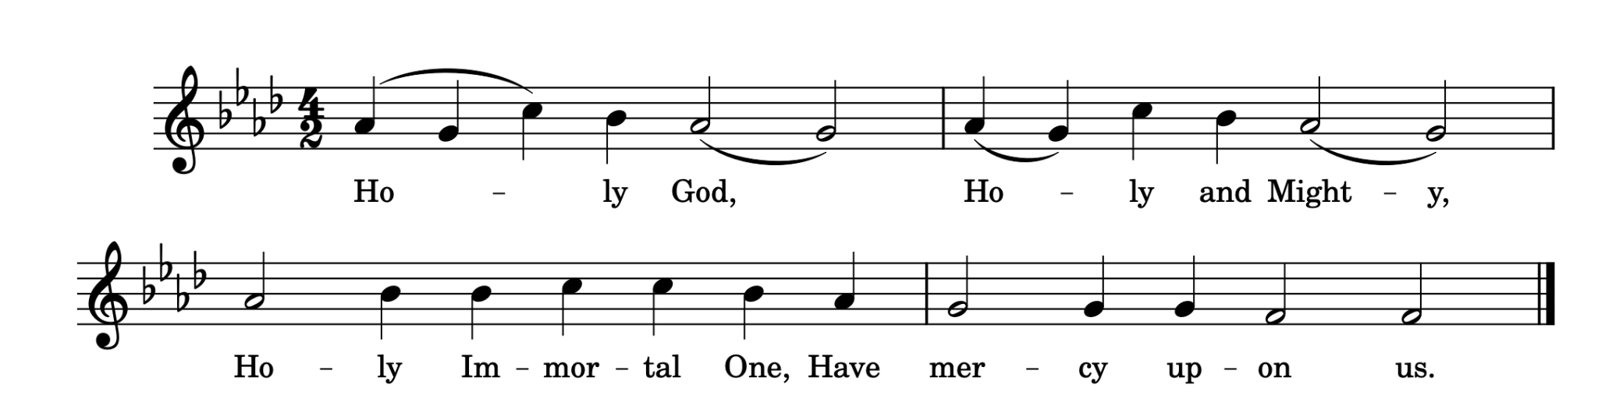The Collect of the Day
Presider Almighty God, whose Son fasted forty days in the wilderness, and was tempted as we are but did not sin, give us grace to discipline ourselves in submission to your Spirit, that as you know our weakness, so we may know your power to save; through Jesus Christ our Lord, who lives and reigns with you and the Holy Spirit, one God, now and for ever. Amen.

Almighty and everlasting God, you despise nothing you have made and forgive the sins of all who are penitent. Create and make in us new and contrite hearts, that we, worthily lamenting our sins and acknowledging our brokenness, may obtain of you, the God of all mercy, perfect remission and forgiveness; through Jesus Christ our Lord, who lives and reigns with you and the Holy Spirit, one God, for ever and ever. Amen.

Presider Let us prepare ourselves for the Word of God
as it comes to us in the reading of Holy Scripture.
All Our hearts and minds are open.

The Proclamation of the Word
(please be seated)
First Reading
Reader A reading from Genesis.
The Lord God took the man and put him in the garden of Eden to till it and keep it. And the Lord God commanded the man, ‘You may freely eat of every tree of the garden; but of the tree of the knowledge of good and evil you shall not eat, for in the day that you eat of it you shall die.’
Now the serpent was more crafty than any other wild animal that the Lord God had made. He said to the woman, ‘Did God say, “You shall not eat from any tree in the garden”?’ The woman said to the serpent, ‘We may eat of the fruit of the trees in the garden; but God said, “You shall not eat of the fruit of the tree that is in the middle of the garden, nor shall you touch it, or you shall die.”’ But the serpent said to the woman, ‘You will not die; for God knows that when you eat of it your eyes will be opened, and you will be like God, knowing good and evil.’ So when the woman saw that the tree was good for food, and that it was a delight to the eyes, and that the tree was to be desired to make one wise, she took of its fruit and ate; and she also gave some to her husband, who was with her, and he ate. Then the eyes of both were opened, and they knew that they were naked; and they sewed fig leaves together and made loincloths for themselves.
Genesis 2:15-17, 3:1-7, NRSVA
Reader Hear what the Spirit is saying to the Church.
All Thanks be to God.

Psalm 32 - Plainsong
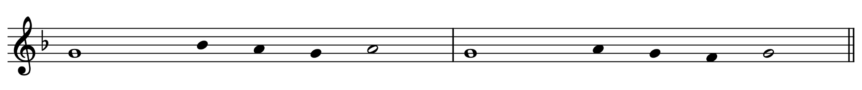Cantor: Happy are they whose transgressions are forgiven,
All: and whose sin is put away!

Cantor: Happy are they to whom the Lord imputes no guilt,
All: and in whose spirit there is no guile!

Cantor: While I held my tongue, my bones withered away,
All: because of my groaning all day long.

Cantor: For your hand was heavy upon me day and night;
All: my moisture was dried up as in the heat of summer.

Cantor: Then I acknowledged my sin to you,
All: and did not conceal my guilt.

Cantor: I said, "I will confess my transgressions to the Lord."
All: Then you forgave me the guilt of my sin.

Cantor: Therefore all the faithful will make their prayers to you in time of trouble;
All: when the great waters overflow, they shall not reach them.

Cantor: You are my hiding-place; you preserve me from trouble;
All: you surround me with shouts of deliverance.

Cantor: "I will instruct you and teach you in the way that you should go;
All: I will guide you with my eye.

Cantor: Do not be like horse or mule, which have no understanding;
All: who must be fitted with bit and bridle, or else they will not stay near you."

Cantor: Great are the tribulations of the wicked;
All: but mercy embraces those who trust in the Lord.

Cantor: Be glad, you righteous, and rejoice in the Lord;
All: shout for joy, all who are true of heart.

Second Reading
Reader A reading from Paul’s Letter to the Romans.
Therefore, just as sin came into the world through one man, and death came through sin, and so death spread to all because all have sinned— sin was indeed in the world before the law, but sin is not reckoned when there is no law. Yet death exercised dominion from Adam to Moses, even over those whose sins were not like the transgression of Adam, who is a type of the one who was to come.
But the free gift is not like the trespass. For if the many died through the one man’s trespass, much more surely have the grace of God and the free gift in the grace of the one man, Jesus Christ, abounded for the many. And the free gift is not like the effect of the one man’s sin. For the judgement following one trespass brought condemnation, but the free gift following many trespasses brings justification. If, because of the one man’s trespass, death exercised dominion through that one, much more surely will those who receive the abundance of grace and the free gift of righteousness exercise dominion in life through the one man, Jesus Christ.
Therefore just as one man’s trespass led to condemnation for all, so one man’s act of righteousness leads to justification and life for all. For just as by the one man’s disobedience the many were made sinners, so by the one man’s obedience the many will be made righteous.
Romans 5:12-19, NRSVA
Reader Hear what the Spirit is saying to the Church.
All Thanks be to God.

Gospel Acclamation – CP #711 David Young

Cantor: Praise to you, O Lord, King of eternal glory.
All: Praise to you, O Lord, King of eternal glory.
Cantor: We shall not live by bread alone, but by every word that proceeds from the mouth of God. Matthew 4.4

All: Praise to you, O Lord, King of eternal glory.

Gospeller Then Jesus was led up by the Spirit into the wilderness to be tempted by the devil. He fasted for forty days and forty nights, and afterwards he was famished. The tempter came and said to him, ‘If you are the Son of God, command these stones to become loaves of bread.’ But he answered, ‘It is written, “One does not live by bread alone, but by every word that comes from the mouth of God.”’ Then the devil took him to the holy city and placed him on the pinnacle of the temple, saying to him, ‘If you are the Son of God, throw yourself down; for it is written, “He will command his angels concerning you”, and “On their hands they will bear you up, so that you will not dash your foot against a stone.”’ Jesus said to him, ‘Again it is written, “Do not put the Lord your God to the test.”’ Again, the devil took him to a very high mountain and showed him all the kingdoms of the world and their splendour; and he said to him, ‘All these I will give you, if you will fall down and worship me.’ Jesus said to him, ‘Away with you, Satan! for it is written, “Worship the Lord your God, and serve only him.”’ Then the devil left him, and suddenly angels came and waited on him.
Matthew 4:1-11, NRSVA

Gospeller The Gospel of Christ.
All Praise to you, Lord Jesus Christ.

Homily
(please stand as you are able)
Silence for reflection

The Apostles’ Creed
Presider Let us confess the faith of our baptism, as we say,
All I believe in God, the Father almighty, creator of heaven and earth.
I believe in Jesus Christ, his only Son, our Lord. He was conceived by the power of the Holy Spirit and born of the Virgin Mary. He suffered under Pontius Pilate, was crucified, died, and was buried. He descended to the dead. On the third day he rose again. He ascended into heaven, and is seated at the right hand of the Father. He will come again to judge the living and the dead.
I believe in the Holy Spirit, the holy catholic Church, the communion of saints, the forgiveness of sins, the resurrection of the body, and the life everlasting. Amen.

Prayers of the People (please assume a position of prayer that is comfortable to you)

Confession and Absolution
Presider Dear friends in Christ, God is steadfast in love and infinite in mercy; he welcomes sinners and invites them to his table. Let us confess our sins, confident in God’s forgiveness.

Presider Most merciful God,
All We confess that we have sinned against you in thought, word, and deed, by what we have done, and by what we have left undone. We have not loved you with our whole heart; we have not loved our neighbours as ourselves. We are truly sorry and we humbly repent. For the sake of your Son Jesus Christ, have mercy on us and forgive us, that we may delight in your will, and walk in your ways, to the glory of your name. Amen.
Presider Almighty God have mercy upon you, pardon and deliver you from all your sins, confirm and strengthen you in all goodness, and keep you in eternal life; through Jesus Christ our Lord.
All Amen.

The Peace (please remain standing)
Presider The peace of the Lord be always with you.
All And also with you.

The congregation is invited to remain standing for the offertory.

Offertory Hymn –Tree of Life and Awesome Mystery - CP#179 1-4, 6b THOMAS

Tree of Life and awesome myst'ry,
In your death we are reborn,
Though you die in all of hist'ry,
Still you rise with ev'ry morn,
Still you rise with ev'ry morn.

Seed that dies to rise in glory,
May we see ourselves in you,
If we learn to live your story
We may die to rise anew,
We may die to rise anew.

We remember truth once spoken,
Love passed on through act and word,
Ev'ry person lost and broken
Wears the body of our Lord,
Wears the body of our Lord.

Gentle Jesus, mighty Spirit,
Come inflame our hearts anew,
We may all your joy inherit
If we bear the cross with you,
If we bear the cross with you.

From the dawning of creation,
You have loved us as your own;
Stay with us through all temptation,
Make us turn to you alone

Text and Music: Marty Haugen, b.1950, © 1984, GIA Publications, Inc

Prayer over the Gifts
Presider God our refuge and strength, receive all we offer you this day, and through the death and resurrection of your Son transform us to his likeness. We ask this in his name. Amen.

The Celebration of the Eucharist

Eucharistic Prayer 3 (please remain standing)
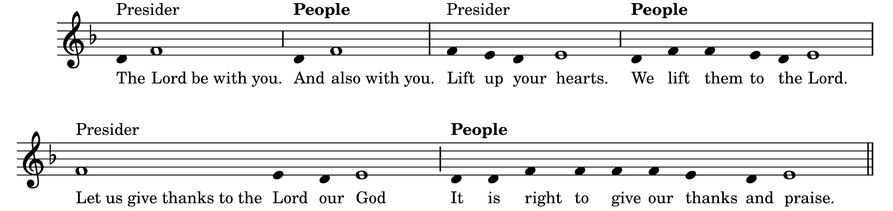

Presider Blessed are you, gracious God, creator of heaven and earth, because you bid your faithful people to cleanse their hearts and to prepare with joy for the paschal feast; that reborn through the waters of baptism and renewed in the eucharistic mystery, we may be more fervent in prayer and more generous in the works of love. Therefore we raise our voices to you in praise to proclaim the glory of your name.

Sanctus & Benedictus – Holy, Holy, Holy, Lord Robert Powell
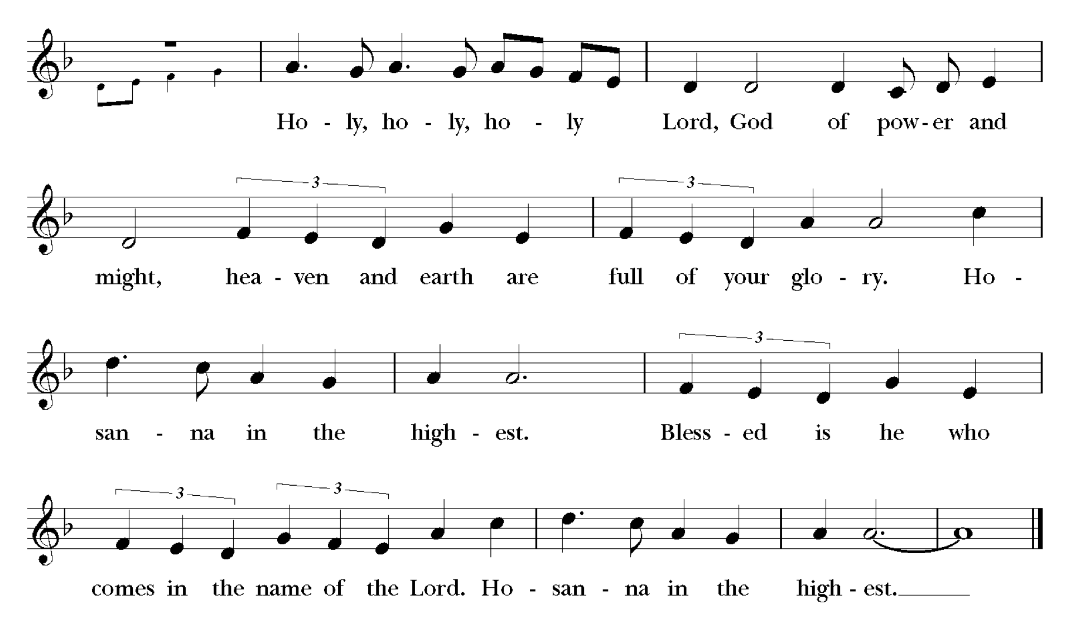

© 1985, Church Publishing, Inc.

Presider We give thanks to you, Lord our God, for the goodness and love you have made known to us in creation; in calling Israel to be your people; in your Word spoken through the prophets; and above all in the Word made flesh, Jesus your Son. For in these last days you sent him to be incarnate from the Virgin Mary, to be the Saviour and Redeemer of the world. In him, you have delivered us from evil, and made us worthy to stand before you. In him, you have brought us out of error into truth, out of sin into righteousness, out of death into life. On the night he was handed over to suffering and death, a death he freely accepted, our Lord Jesus Christ took bread; and when he had given thanks to you, he broke it, and gave it to his disciples, and said, “Take, eat: this is my body which is given for you. Do this for the remembrance of me.” After supper he took the cup of wine; and when he had given thanks, he gave it to them, and said, “Drink this, all of you: this is my blood of the new covenant, which is shed for you and for many for the forgiveness of sins. Whenever you drink it, do this for the remembrance of me.”

Therefore, Father we proclaim our hope,

All 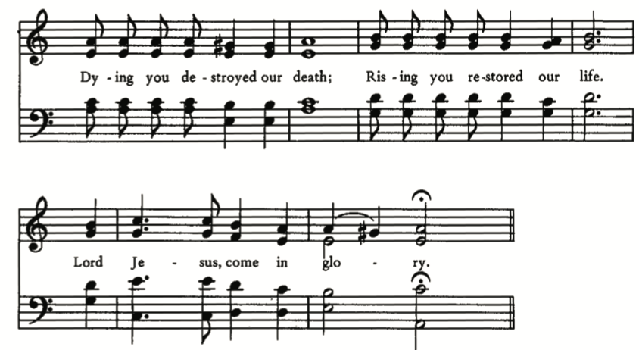

Presider We offer our sacrifice of praise and thanksgiving to you, Lord of all; presenting to you, from your creation, this bread and this wine. We pray you, gracious God, to send your Holy Spirit upon these gifts, that they may be the sacrament of the body of Christ and his blood of the new covenant. Unite us to your Son in his sacrifice, that we, made acceptable in him, may be sanctified by the Holy Spirit. In the fullness of time, reconcile all things in Christ, and make them new, and bring us to that city of light where you dwell with all your children; through Jesus Christ our Lord, the firstborn of all creation, the head of the Church, and the author of our salvation; by whom, and with whom, and in whom, in the unity of the Holy Spirit, all honour and glory are yours, almighty Father, now and for ever. Amen.

The Lord's Prayer – CP #684 John Merbecke
Presider As our Saviour taught us, let us pray:
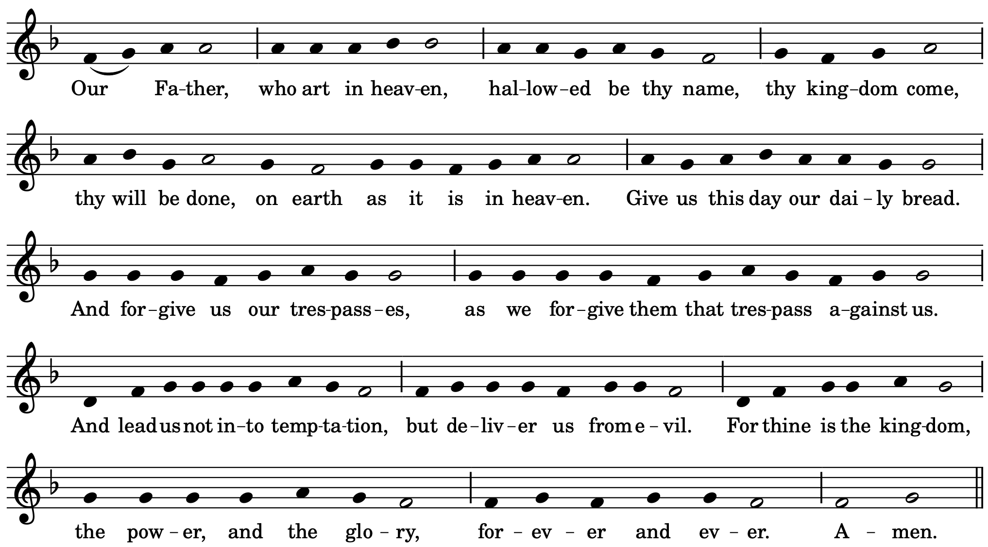
Breaking of the Bread
Presider We break this bread,
All Communion in Christ’s body once broken.

Presider Let your Church be the wheat which bears its fruit in dying.
All If we have died with him, we shall live with him; if we hold firm, we shall reign with him.
(please be seated)
Agnus Dei – Lamb of God Paul Jernberg
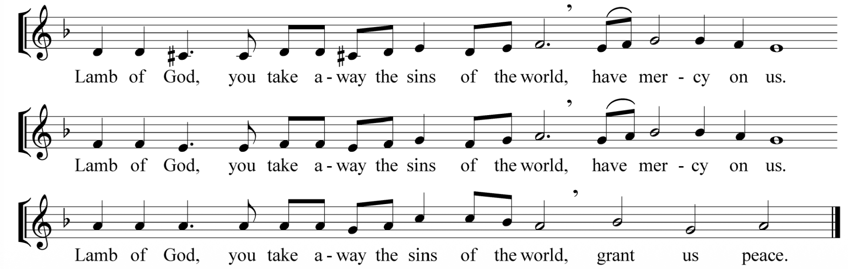

© 2011 Paul F. Jernberg

Choral Anthem – Call to Remembrance Richard Farrant

Call to remembrance, O Lord,
thy tender mercy and thy loving kindness which hath been ever of old.
O remember not the sins and offences of my youth,
but according to thy mercy think thou on me, O Lord, for thy goodness.
-Psalm 25: 5,6

Communion Hymn – Let Us Break Bread Together LET US BREAK BREAD TOGETHER

1 Let us break bread together on our knees;
Let us break bread together on our knees;
When I fall on my knees;
With my face to the rising sun,
O Lord, have mercy on me.
2 Let us drink wine together on our knees;
Let us drink wine together on our knees.
When I fall on my knees;
With my face to the rising sun,
O Lord, have mercy on me.
3 Let us praise God together on our knees;
Let us praise God together on our knees;
When I fall on my knees,
With my face to the rising sun,
O Lord, have mercy on me.
Text and Music: African-American Tradition

Prayer after Communion (please stand as you are able)
Presider Faithful God, in this holy bread you increase our faith and hope and love. Lead us in the path of Christ who is your Word of life. We ask this in his name. Amen.

Presider Glory to God,
All whose power, working in us, can do infinitely more than we can ask or imagine. Glory to God from generation to generation, in the Church and in Christ Jesus, for ever and ever. Amen.

Blessing
Presider May the God of Freedom, who leads you into all life, deliver you from every evil and make you deliverers of others. And may the blessing of God Almighty –Liberator, Redeemer, and Empowerer–be upon you and remain with you always. Amen.
Announcements

Closing Hymn – Forty Days and Forty Nights - CP#175 HEINLEIN (AUS DER TIEFE)
1 Forty days and forty nights
you were fasting in the wild;
forty days and forty nights
tempted, and yet undefiled:
2 burning heat throughout the day,
bitter cold when light has fled,
prowling beasts around your way,
stones your pillow, earth your bed.
3 Shall not we your trials share,
learn your discipline of will,
and with you by fast and prayer
wrestle with the powers of hell?
4 So if Satan, pressing hard,
soul and body would destroy:
Christ who conquered, be our guard;
give to us the victor's joy.
5 Saviour, may we hear your voice -
keep us constant at your side;
and with you we shall rejoice
at the eternal Eastertide.

Text: George Smyttan ©1982 Hope Publishing Music: att. Martin Herbst
Dismissal (please stand as you are able)

Clergy Go forth in the peace of Christ.

All Thanks be to God. Amen.

Postlude O Mensch, bewein dein Sünde Groß, J.S. Bach
“O Man, Bewail Thy Great Sin” BWV 622

Thank you for worshipping with us this morning.
Please join us for refreshments in Elliott Hall.

Musical notes
This Lent, you will notice a few changes to our musical practices to reflect the penitential nature of the season. At the 10:30am service, the choir will offer introits, which are short choral pieces intended to help us quiet our minds and ready our hearts for worshipping God. In place of the Gloria, we will sing the Trisagion, an ancient hymn of Eastern Christian origins imploring God's mercy. Alleluias are also suppressed. Other hymns, service music, and postludes will generally be more reflective and subdued in tone. There will also be more silence in services. For centuries, liturgical rubrics have recommended musical austerity during penitential seasons; through this restraint it is hoped that we will better be able to reap the fruits of Lenten disciplines and thus more fully experience the joy of the Resurrection in the Easter season.

This Sunday, our Black History Month musical feature is the choral introit, "O Holy Saviour," composed by the African-American composer Ulysses Elam, as arranged by the Black Canadian choral composer Nathaniel Dett. The communion hymn, "Let Us Break Bread Together on Our Knees" is an African-American spiritual, that was also used as a code by enslaved peoples planning escapes and gatherings through the Underground Railroad.

Assisting with the Liturgy
Presiding Celebrant: Rev’d Alison Falby
Homilist: Elsa Jones
Director of Music & Organist: Stefani Bedin
Choir Section Leads: Emily Ding, Julia Barber, Martin So, Peter Warren
Subdeacon: Elsa Jones
Crucifer: Sunkanmi Kazeem
Reader: Winnie Tang
Prayers of the People: Nigel Johnson
Warden on Duty: Paul Kingston
Sidesperson: Angelito Pena
Livestream Technician: Nate Denton
Verger: Rikk Scapillato

Next Week’s Worship Preview:

Second Sunday in Lent–March 1, 2026
Genesis 12:1-4A, Psalm 121, Romans 4:1-5, 13-17, John 3:1-17

Presider: Rev. Alison Falby
Homilist: Rev. Cathy Gibbs

Hymns: The God of Abraham Praise | Lord Jesus, Think on Me | O Kind Creator | Now Let Us All With One Accord
Choral Introit: R.R. Terry- Richard de Castre’s Prayer to Jesus
Choral anthem: B. Chilcott- God So Loved the World
Sources Music reprinted & streamed with permission under One License #A-724916 and under CCLI Inc. #11419375. All rights reserved.
Blessing based on “Freedom Prayer” from the International Anglican Women’s Network, Freedom Sunday: Resources for Worship and Action (2014) p. 18, https://iawn.anglicancommunion.org/media/210016/Freedom-Sunday-resources-for-worship-and-action.pdf (accessed February 17, 2026).

Visitor Information
Hearing Assistance Devices are located on the table beside the bell-tower entrance. Large Print Orders of Service are available.

Participating in the Offertory
Thank you for your faithful generosity. Running our church is a significant undertaking that allows us to serve our congregation and the neighbourhood. Our essential weekly operating costs total approximately $20,000. Your contributions support everything from maintaining our sacred space to funding vital community programs and staff salaries. Your ongoing support is deeply appreciated.


